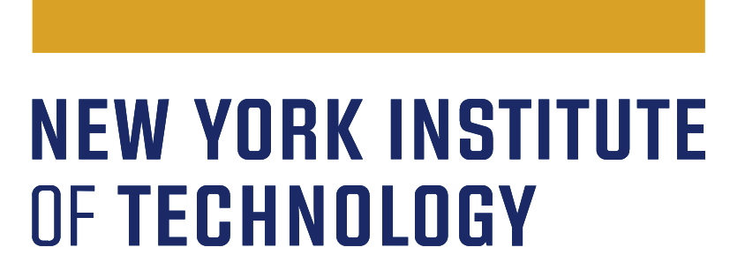

**Continuous Program Improvement (CPI)**

**Student Support Offices - Student Success/Achievement**

**Plan Implementation Report - AY 2024-25**

| **Office name** |  |
| --- | --- |
| **Expected date of submission** | 6/30/2025 |
| **Office head/director** |  |

New York Tech’s CPI process is implemented to meet Middle States Commission on Higher Education (MSCHE) Standard V: *Educational Effectiveness Assessment*, which states: “Assessment of student learning and achievement demonstrates that the institution’s students have accomplished educational goals consistent with their program of study, degree level, the institution’s mission, and appropriate expectations for institutions of higher education.”

Each student support office was asked to create a three-year assessment/evaluation plan to improve **student success/achievement** covering the following academic years: **2022-2023, 2023-2024, and 2024-2025.**

All offices’ three-year CPI plans are available here: <https://www.nyit.edu/planning/cpi_annual_reports>

This is a report on the student success/achievement CPI plan **implementation** for the **2024-25** academic year.

1. Please respond to the feedback provided by the CPI Committee in response to your AY 2023-24 CPI Plan Implementation Report. How did you incorporate the Committee’s recommendations into your CPI efforts?
2. Please address the following points in this year’s (AY 2024-25) report:

1. Briefly describe the actions taken to achieve the improvement goals in each of the functional areas
2. What qualitative and quantitative key performance indicators (KPIs) were used to assess the actions’/initiatives’ effectiveness?
3. What were the actual results for all the measures (KPIs) on each of all your office’s functions and improvement goals for AY 24-25?
4. Does the data/evidence show that the actions/initiatives implemented have been effective in achieving the goals you aim for in your plan?
5. Close the loop: If the actions/initiatives were successful, describe how you will keep or expand the good practices. If they were not successful, explain how you have or will refine the plan and begin the next cycle of [Plan-Do-Study-Act (PDSA)](https://www.nyit.edu/planning/demings_model_for_continuous_improvement).

1. Describe how staff in your office were involved in the implementation of the student success/achievement CPI plan and how the results will be communicated to all stakeholders.

Report example - Academic Advising CPI Report (AY24-25)

| Improvement goals | KPI (measure of success) | Baseline-3 year historical trend | Improvement goals with KPIs (2023-2026) | Strategic actions | Responsibilities & Timeline | Results for 24-25 | Closing the loop |
| --- | --- | --- | --- | --- | --- | --- | --- |
| *Academic Advising – Reduce the number of students on academic probation* | *# and % of students on probation*  *Student satisfaction ratings of advising services* | *2020-2021: 23% (127/639) 2021-2022: 20% (170/850) 2022-2023: 21% (180/861)* | *Decrease probation rate to 18% or lower*  *80% or higher Student satisfaction with our services* | *We will enhance our advice and registration process by maintaining a fully staffed team. We will continue our weekly Tuesday to-dos and increase advisor communication to their caseloads through individual messaging over the summer.* | *The associate director will oversee the collection and analysis of data by the end of each academic year.* | *The probation rate for AY 23-24 was 19%, a decrease from last year, but not meeting our goal 18% yet.* | *In addition to what we have been doing in the last year, we will implement a survey to collect instant student feedback to improve the effectiveness of advising.* |